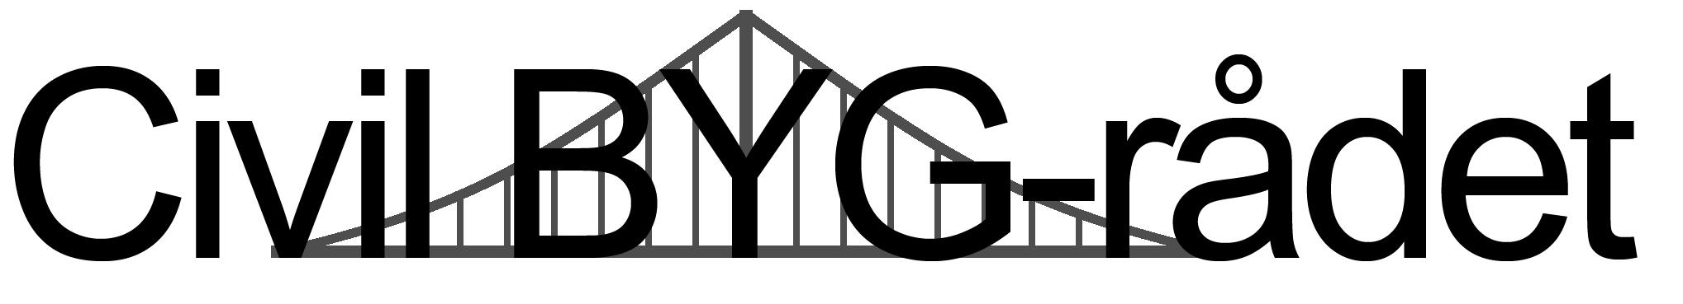

Civil BYG study council meeting
27-11-2019
Location: Charlie
Kitchen: Yes
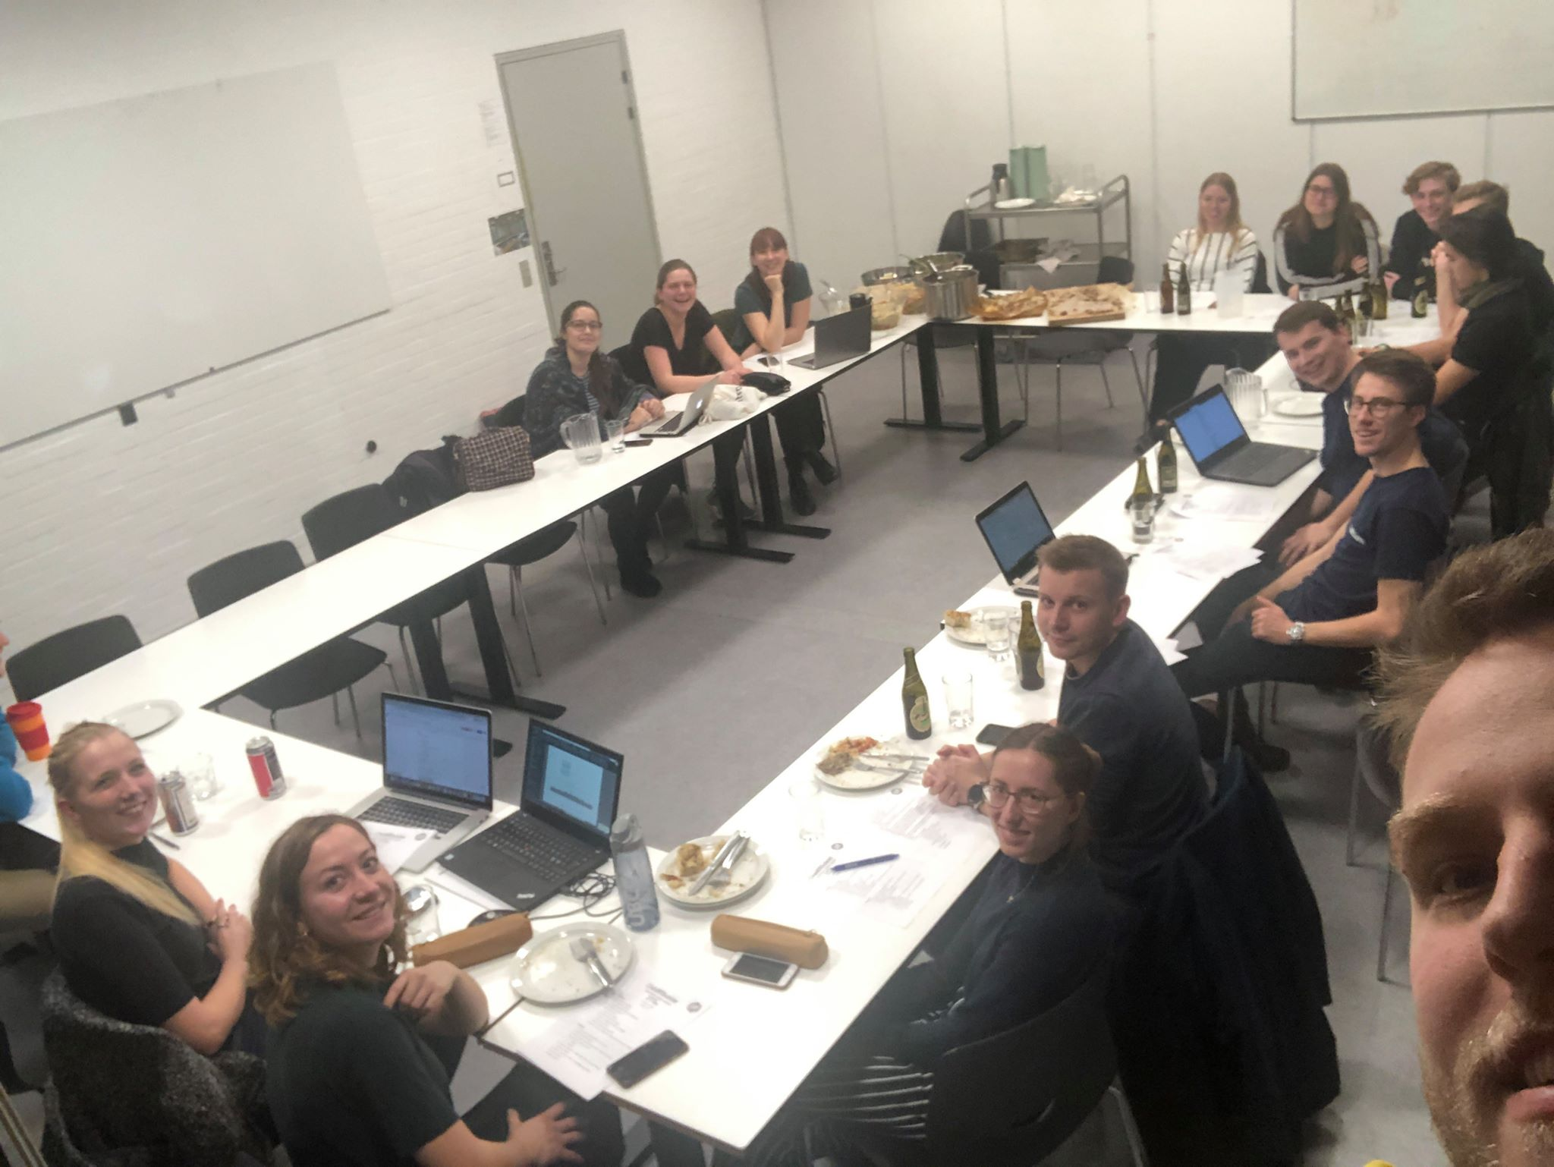
- Formalities
  - Election of mediator:
    - Ida
  - Election of secretary:
    - Nikolas
  - Approval of last meeting’s minutes (Link):
    - No list of the attendees
    - No picture
    - With these changes the minutes are approved.
  - Approval of agenda:
    - Approved
  - Present:
    - Ida Hoffmann
    - Nikolas Holm Poulsen
    - Louise Nørgaard Nielsen
    - Marie Strom
    - Peter Garlet Rank
    - Charlotte Sommer
    - Sofie Bøwig Rasmussen
    - Jacob Høegh-Jørgensen
    - Magnus Toxværd
    - Frederikke Spies
    - Sara Jørgensen
    - Daniel Eriksen
    - Mads Kim Krarup
    - Nikolaj Horhiem Hansen
    - Marie Rodriguez
    - Anders Brandt-Jørgensen (ikke konstitueret)
    - Søren, B19
  - Date for next meeting:
    - Tuesday the 14th of January 2020
  - Election of readers of minutes:
    - Charlotte & Sofie
  - Election of “hyggeansvarlig” for next meeting:
    - Frederikke & Marie
  - Chefs for next meeting:
    - TBA
  - Election of dishwashing responsible:
    - Mads
  - Payment for dinner - MobilePay to Daniel Eriksen 28 49 30 51: DKK 20

- Messages
  - Joint council – Fællesrådet (Ida, Tox and Sara):
    - Master Student Coordinators have been elected.
    - Sensommerfest
      - We had a (very long) discussion about the future of SSF.
      - A group has been established to go through all of the points from the discussion.
      - If you have any points that you want to make sure that was brought up or want to get in contact with the group ask Ida and she’ll figure out how to reach them.
    - University election
      - Election for the study boards, DTU board etc.
      - No one has run against PF so everyone running has been elected.
    - Academic Council
      - Benjamin Lam, Søren Kuhberg and Magnus Koch as ordinary members and Emil Kristiansen and Magnus Andreasson as alternate members.
    - Confidentiality among PF volunteers
      - A contract had been made
      - However, the consequences of breaking it were a bit harsh and it should be reviewed by someone with a bit more knowledge on law.
    - Senior members of PF shall now pay DKK 150 every year.
    - The new even committee
      - The group of people running were all elected.
  - COBS19 – KABS19 (Mette):
    - Remember to be nice to the ones running for KABS - also the ones from the other study lines. There are a lot of people running so they’re under quite a lot of pressure <3
    - Sober event. Not that many rushers at the movie night.
  - Social committee – Socialpolitisk udvalg (Sabine, Magnus and Anders):
    - Nothing new
  - Study boards – Institutstudienævn:
    - ISN Byg
      - The meeting calendar of 2020 has been set
        - 09/01
        - 20/02
        - 23/04
        - 17/06
        - 22/09
        - 11/11
      - Licenses:
        - ANSYS
          - In the course “CFD in Buildings” the students are asked to download the latest version.
          - However, the computers at DTU are running an older version, which isn’t compatible with the new one.
      - Renovation of B116 will start as planned on February 1st 2020
        - The east wing will not be affected by the renovation. There will thereby be access to “Bønnen” throughout the renovation (however, not in the summer holiday)
        - Diagonalen will not be affected by the renovation - except for the large parties.
        - De studerende samler info sammen om fejl, mangler, problemer og begrænsninger og afleverer til Per senest 6. december - Skriv derfor gerne til David hvis i har noget der skal med s163781@student.dtu.dk
        - Online toolbox til BIM som skulle udvikles er gået lidt i stå
    - ISN Mek
      - Nothing new
  - Academic committee – Fagligudvalget (Rojan, Daniel and Kirstine):
    - Nothing new
  - Diagonalen (Mads):
    - Still looking for bartenders (You can apply until Tuesday)
    - BYG 100 will be on the first Friday in the 3-week period in January.
    - You can get 36 liter beer in Bilka/Føtex /3600 special beers for 90k
  - Work environmental committee – Arbejdsmiljøudvalg (Daniel):
    - New actions regarding chemistry
    - Trying to establish a working group in Greenland. However, this hasn’t been done yet.
    - When doing the safety test in English there are some errors, which should be fixed right away.
  - PF board (Søren):
    - International Committee
      - Throwing a Karaoke event on December 4th - come by and show some support!
    - If you want to help out with planning some events in PF join this group https://www.facebook.com/groups/PFevents/. It’s completely non-committing, but you’ll be notified when the event committee will need some help.
    - There are 3 new ovens in the PF kitchen, which have been funded by Noget-For-Noget-fonden. Please take good care of them.
    - Huts and the study start
      - We’re losing 7 huts in 2021 (+1 independant hut)
      - We need to treat the huts better
      - The “cabin-parents” complain a lot about the alcohol consumption at the trips.
      - There’s this idea going around that we’re better than a lot of the other universities (e.g. CBS) and that the cabin-parents like us. This is not always the case though.
      - There are complaint from neighbours as well.
      - We want to continue to have the best study start - also for the people renting out their cabins.
      - Comments from Bygrådet:
        - The drinking culture on the trips can at times be too much.
        - Maybe it’s not so bad that some of the trips are a bit further away (e.g. Fyn)
  - Economy (Daniel):
    - Sensommerfest 18:
      - BIX - some expenses have not been paid by us.
      - There’s an expense of 400kr for food for the people guarding the tents. This isn’t something that we usually pay for.
  - Kaffebønnen (Mads):
    - Renovation of B116:
      - The area towards the yard next to bønnen will be blocked. The toilets will become unisex.
      - There will still be lectures in the smaller rooms in the same hall as Diagonalen.
      - Bønnen will not close during or after the renovation. There will not be a PF/DTU driven café in B116.
      - All the auditoriums will be renovated (the drawings look very nice).
  - FOLLOW GROUP (monitoring of BSc Civil Engineering) – Følgegruppe (Lars, Tobias and David)
    - Nothing new
- The election for the board of PF 2020
  - Questions for the candidates:
    - President:
      - What makes you a better president than the two other candidates?
        - (Hvorfor vil du være en bedre formand end de to andre?)
      - Do you see any possible difficulties with working together with any of the other people running for B20?
        - (Kunne du forestille dig, at der kunne opstå samarbejdsvanskeligheder med nogen af de andre opstillede til B20?)
      - In case you’re not elected president, are you then planning on running as an ordinary member? If yes, which areas could you imagine yourself working with?
        - (Hvis du nu ikke bliver valgt som formand, stiller du så op som ordinært medlem? Hvis ja, hvilke ansvarsområder, kunne du forestille dig at varetage?)
      - If you become the board contact in this council, how much cake are you planning on bringing?
        - Hvis du bliver vores bestyrelseskontakt, hvor mange gange har du så tænkt dig at tage kage med?
      - If you were to design a new building here at DTU, which material would you choose for the load carrying system?
        - Hvis du skulle bygge en ny bygning på DTU, hvilket materiale ville du så opbygge det statiske system af?
    - CFO:
      - What makes you a better CFO than the two other candidates?
        - (Hvorfor vil du være en bedre FRRF end de to andre?)
      - Do you see any possible difficulties with working together with any of the other people running for B20?
        - (Kunne du forestille dig, at der kunne opstå samarbejdsvanskeligheder med nogen af de andre opstillede til B20?)
      - What would you specifically do in order to prevent that too much PF knowledge is lost when Inge retires?
        - (Hvordan du du konkret sørge for, at der ikke er for meget viden/hukommelse, der går tabt, når Inge går på pension?)
      - In case you’re not elected CFO, are you then planning on running as an ordinary member? If yes, which areas could you imagine yourself working with?
        - (Hvis du nu ikke bliver valgt som FRRF, stiller du så op som ordinært medlem? Hvis ja, hvilke ansvarsområder, kunne du forestille dig at varetage?)
      - If you become the board contact in this council, how much cake are you planning on bringing?
        - Hvis du bliver vores bestyrelseskontakt, hvor mange gange har du så tænkt dig at tage kage med?
      - If you were to design a new building here at DTU, which material would you choose for the load carrying system?
        - (Hvis du skulle bygge en ny bygning på DTU, hvilket materiale ville du så opbygge det statiske system af?)
    - Ordinary:
      - Do you see any possible difficulties with working together with any of the other people running for B20?
        - (Kunne du forestille dig, at der kunne opstå samarbejdsvanskeligheder med nogen af de andre opstillede til B20?)
      - Which areas/responsibilities do you see yourself with in a board?
        - (Hvilke ansvarsområder kunne du forestille dig selv at varetage i en bestyrelse?)
      - If you become the board contact in this council, how much cake are you planning on bringing?
        - (Hvis du bliver vores bestyrelseskontakt, hvor mange gange har du så tænkt dig at tage kage med?)
      - If you were to design a new building here at DTU, which material would you choose for the load carrying system?
        - (Hvis du skulle bygge en ny bygning på DTU, hvilket materiale ville du så opbygge det statiske system af?)
  - Anders Bogh Jacobsen:
    - Running for: President
      - Inge - what should we do?
      - Evening module - what’s going to happen?
      - International committee - let’s get more international students in PF
    - Questions:
      - Bottom of page 1: which benefits are you referencing to specifically?
      - What makes you a better president than the two other candidates?
        - Will focus on a lot of the same things as the two others. However, with a larger focus on Ballerup and the international students.
        - I’m calm, down to earth, structured, and have experience with planning of SSF.
      - New politics?
        - Evening module
        - Inge
        - Accreditation
      - How are you planning on running PF when SSF isn’t going that great?
        - Issues were caused by a lack of volunteers - some councils have chosen to no longer participate.
      - Do you see any possible difficulties with working together with any of the other people running for B20?
        - Nope. Have experienced working with the others.
      - In case you’re not elected president, are you then planning on running as an ordinary member? If yes, which areas could you imagine yourself working with?
        - 99% certain that I’ll run. Probably work with social politics.
      - If you become the board contact in this council, how much cake are you planning on bringing?
        - Min. 1 cake
      - If you were to design a new building here at DTU, which material would you choose for the load carrying system?
        - Fancy white concrete
  - Louise Frost:
    - Running for: President
      - Thank you for having me.
      - Motivation and recruitment of volunteers.
      - Kampagne: Your future with PF
      - Analysis of volunteers
      - Idealism & realism
      - More volunteers!
    - Questions:
      - What makes you a better president than the other two?
        - More weight of volunteer competences (the kampagne)
          - Possibly use PF alumni
        - Good competences regarding communication
      - Internationals & Ballerup?
        - It’s important to have a focus on these two groups.
          - And to get members from these two groups in order to properly represent all DTU students.
      - How many board members would you prefer?
        - Between 7 and 9 - depending on the members. Many members isn’t necessarily a good thing.
      - Do you see any possible difficulties with working together with any of the other people running for B20?
        - No
      - In case you’re not elected president, are you then planning on running as an ordinary member? If yes, which areas could you imagine yourself working with?
        - Will figure it out at the time.
        - The working area will be worked out on Sunday. All areas can be interesting
      - If you become the board contact in this council, how much cake are you planning on bringing?
        - More than Søren. But it might not be cake.
      - If you were to design a new building here at DTU, which material would you choose for the load carrying system?
        - Something sustainable

  - Søren Sandgaard:
    - Running for: President
      - Transparency in PF. Put some light on other aspects than the study start.
      - Bette representation of PF.
    - Questions:
      - What makes you a better president than the two others?
        - Focus on volunteers and that the members should feel like a part of PF.
          - Idea with posters where everyone can write their suggestions.
            - Draw on experience from previous kampagne
          - In general we should be better at using our previous experiences - also regarding events.
      - Do you see any possible difficulties with working together with any of the other people running for B20?
        - All 9 a competent
        - Can be a good board if all 9 put in the work.
      - What if the board only consisted of 5-6 members?
        - Would be hard on PF.
      - In case you’re not elected president, are you then planning on running as an ordinary member? If yes, which areas could you imagine yourself working with?
        - Will consider it tomorrow.
        - Social area.
      - If you become the board contact in this council, how much cake are you planning on bringing?
        - Søren-standard (a new Søren-standard)
      - If you were to design a new building here at DTU, which material would you choose for the load carrying system?
        - Concrete

  - Jakob Rydhof:
    - Running for: CFO
      - 3.5 years in the Financial Committee (Forretningsrådet)
      - Welcome the “new Inge”
      - Experience from company (Corporate MSc Eng programmes) for a while.
      - Work environment.
    - Questions:
      - Experience with commercial law?
        - C-level course in high school (HHX) & master class (Basic understanding of the subject)
      - What makes you a better CFO than the two others?
        - Experience from gap year and student job.
      - Do you see any possible difficulties with working together with any of the other people running for B20?
        - No
      - Would 9 people in a board be too many?
        - No, as Charlotte (new Inge) is starting.
      - Do you expect any issues with people not getting their 1st priority? (regarding responsibilities and posts in the board)
        - Maybe when someone doesn’t get the areas that they’re the most interested in.
      - Savings in PF?
        - Expensive systems on campus.
        - Optimizing expenses.
        - Possibly fewer administrative costs.
      - Vision for more catering/cafées around campus?
        - Could work. However, I think that PF should keep its current size.
      - Support for “kaffebønnen”?
        - Support, but not overtake.
      - In case you’re not elected CFO, are you then planning on running as an ordinary member? If yes, which areas could you imagine yourself working with?
        - Maybe
        - Academic politics (Uddannelsespolitik) and financial affairs.
      - If you become the board contact in this council, how much cake are you planning on bringing?
        - 1 very good cake
      - If you were to design a new building here at DTU, which material would you choose for the load carrying system?
        - Concrete

  - Linus Knoop:
    - Running for: CFO
      - 2 large tasks in PF
        - financial management and quality (also regarding the “new Inge”)
        - Support of the study councils’ financial management so that they can keep track of their economy.
    - Questions:
      - You wish to divide the working tasks?
        - In order to make sure that everything is running smoothly (e.g. regarding Charlotte)
        - Has discussed this with the others that are running.
        - Some tasks doesn’t have to be taken by the CFO.
      - Is C5 too expensive? Would a new system?
        - Not as expensive as other programmes.
        - Very comprehensive to change to system.
      - Is C5 too old fashioned? An online alternative?
        - C5 isn’t that difficult once you’ve learned it.
        - An online alternative is worth looking into.
      - Focus on economy and financial management?
        - Overview of the tasks, transfer of experience which then can be improved by standardisation.
      - Is 9 an appropriate number on board members? Too many?
        - There’s a lot to do, so 9 is an appropriate number.
        - Ideally everyone should get to work with what they find the most interesting.
      - What makes you a better CFO than the two others?
        - Different background - stronger support base.
        - Connections from another organisation.
        - His father is head of studies at DTU Diplom.
      - What’s your plan for your studies, if you’re elected for the board?
        - 15 ECTS/semester
      - Do you see any possible difficulties with working together with any of the other people running for B20?
        - No
      - In case you’re not elected CFO, are you then planning on running as an ordinary member? If yes, which areas could you imagine yourself working with?
        - Yes!
        - Support the CFO. Otherwise coordinator of social politics.
      - If you become the board contact in this council, how much cake are you planning on bringing?
        - More than Søren (B19), minimum 2 cakes.
      - If you were to design a new building here at DTU, which material would you choose for the load carrying system?
        - Concrete

  - Vinh Duy Nguyen:
    - Running for: CFO
      - Experience with the work.
      - Inge-focus
      - Study council economy
        - Running financial reports (Løbende regnskab)
    - Questions:
      - New methods for study council budgets/economy?
        - Maybe an update of the accounts programme
        - Current method might not be that big a burden.
      - Is C5 too expensive? Cheaper alternative?
        - Depending on the situation certain expenses can be considered, wher eafter the whole can be reconsidered.
      - What makes you a better CFO that the other two?
        - Insight in the last years of PF and PF’s history.
        - Mentioned that it should just be better this year but also in 3, 5 and 10 years into the future.
      - Thoughts of Sensommerfest? (where you were in charge of the economy)
        - There are errors in the way that the economy of SSF in being controlled. He has worked hard on making up for a mistake made years ago.
      - If you become the board contact in this council, how much cake are you planning on bringing?
        - More than Søren (B19)
      - If you were to design a new building here at DTU, which material would you choose for the load carrying system?
        - Bamboo

  - Johan Emil Levin-Jensen:
    - Running for: Ordinary
      - Ensuring quality of evening courses and of intake(optag)
      - Language barrier on the Masters.
      - GE
    - Questions:
      - Evening courses? Solution?
        - Affects the social.
        - “Half” module (dvs. 15-17 - 18-20?)
      - Increased intake on DTU?
        - DTU are accepting too many students.
      - Do you see any possible difficulties with working together with any of the other people running for B20?
        - Good experience with working with the others.
      - Master study council?
        - Would like to see a master study council. However, it needs help to get started.
        - Could be a task for the board - similar to the International Committee
      - To large a board with 9 members?
        - Different areas - not too large. Room for extra task and division of areas.
      - Which areas could you imagine yourself working with in a board?
        - Possibly coordinator of academic affairs
      - If you become the board contact in this council, how much cake are you planning on bringing?
        - Once in a while
      - If you were to design a new building here at DTU, which material would you choose for the load carrying system?
        - Steel

  - Kristian Munch Kielsgaard Nielsen:
    - Running for: Ordinary
      - Pf from 2016
      - Study environment
      - Sees a large difference in the competencies in the people running for the board.
    - Questions:
      - Can 9 people be too many in a board?
        - Not as far as he can tell.
        - Inge will retire - a good thing with a lot of hands.
      - Do you see any possible difficulties with working together with any of the other people running for B20?
        - No
      - Which areas could you imagine yourself working with in a board?
        - Administrative tasks
        - “Workhorse” of the board.
      - Experience with similar tasks?
        - Chairman at a café.
      - If you become the board contact in this council, how much cake are you planning on bringing?
        - Will bring cake for the last meeting
      - If you were to design a new building here at DTU, which material would you choose for the load carrying system?
        - No clue. Polyester could be fun

  - Lucas Jean Louis Gramme:
    - Running for: Ordinary
      - 22, 3. semester software
      - Love volunteers and study environment
      - There’s a need for good communication paths.
    - Questions:
      - President of S-huset?
        - Yes
      - How is S-huset run at the moment?
        - Communication si lacking. Needs improvement. Especially the communication of experience.
      - Do you have time besides from your other tasks?
        - Yes
      - Too Good To Go?
        - Would be great to use the sandwiches that are thrown out the moment (it is underway)
      - Is 9 too many?
        - Might be. 7-8 would be a good amount of people.
      - Do you see any possible difficulties with working together with any of the other people running for B20?
        - Nope
      - Which areas could you imagine yourself working with in a board?
        - S.hus president
        - Maybe coordinator of social politics - internal politics.
      - Better transfer of experience (overlevering)?
        - “How to”-descriptions. More of these including written experiences.
      - Coffee cups?
        - Another subject. Cups in kælderbaren and vernes should be recyclable.
        - Possibly straws made of pasta.
      - If you become the board contact in this council, how much cake are you planning on bringing?
        - Often
      - If you were to design a new building here at DTU, which material would you choose for the load carrying system?
        - Reinforced concrete!

- Election for COBS for Civil Engineering
  - Running: Sofie Bøwig Rasmussen
    - Was actually planning to be a vector for the second time, but Mette talked me into it.
  - Questions:
    - Visions?
      - More events for “tværholdet”, that you meet on the rush trip.
      - Possibly gather the people from the trips for events, which are already there.
    - Dispute between study lines?
      - It’s a shame. It would be awesome to have a better relationship with D. Byg.
    - Anything you wish to do different with the study start on C.Byg?
      - It’s currently working pretty well.
    - Did you experience any negative attitudes regarding the sober event?
      - Yes. It didn’t end with a success …
      - Sober events are a great way to obtain closeness with the freshers.
      - KABS could be better at emphasizing the sober events. It affects the vectors that thereby the freshers.
    - Will you draw on experience from previous study starts?
      - Yes
    - Regarding the instagram profile (Byg-Beton). What are your thoughts?
      - The Instagram doesn’t work very well and is rarely used.
    - Do you experience any serious disputes or a lack of common respect between study lines?
      - Nothing serious.
    - How visible are you planning on being at events?
      - Will, as far as possible, be present at events together with the vectors.
  - Election (vote of confidence)
    - Conclusion: Everyone in the council would be happy to have her as KABS
- FR301 (without the board election)
  - Evaluation of bonusKABS system
    - They don’t want to continue with it.
  - Election of KABS
    - Is there one or more people of the list of candidates, that we cannot support?
  - Election of the Finance Council
    - Currently noone is running. You’ll have until tomorrow to run.
  - Approval of the accounting
    - It is what it is. It looks fine.
  - Presentation of Critical Audit (2018/2019) - Kritisk Revision
    - Audit of PF. There’s a report if you’re interested
    - Det sker. Rapport er lagt op
    - We are one of the 4 (out of 19) councils that actually have open minutes and upload them to PF.dk
- Status on the future use of bygrummet
  - The room has been cleaned and looks a lot better (fun fact: we found a pepsi which expired in 2017)
  - We haven’t done much else yet.
  - CAS has found another room for their cleaning supplies (woop)
- Status on evaluation of the Master’s curriculum (Ida, Lukas, Mette, David and Gunge)
  - No news
- Status on course dating in January (David, Ida and Mads)
  - It’ll be on January 8th
  - Posters have been made.
  - Jens and Per will be there.
  - We might need someone for marine structures.
- Status on “Bygfest” (Lukas, Helene, Mads, Jacob and Nikolas)
  - It’ll be in Osten on February 28th. Mark the calendar.
  - They have it under control
- Status on Christmas lunch (Jonas Krintel, Maria Storm, Peter and Sabine)
  - 25th January
  - Booked Delta
  - Nybrogaard-dorm (Maybe we can book the kitchen?) (It’s been booked!)
  - Need help for cooking
  - Ca. 50 kr
- Status on cabin trip (Kim, Jacob, Lena, Amanda og Nikolas)
  - Nothing new.
  - “Bumse-problem”. Who can we ask?
    - Doesn’t have to be someone that has graduated from civil engineering (e.g. Heegaard and Styrbæk were there on the last cabin trip)
- Status on “the master student project” (Julie, Helene, Sara, Lukas, Ida and Mads)
  - No news
- Evaluation of course dating for studying abroad (Lukas, Mads and Nikolaj)
  - One from each continent
  - Only about 4-5 people showed up
  - Maybe a date earlier in the semester next time. (around october)
  - Maybe combine it with the other course dating
- Status on “byggerne bowler og buldrer” (Lena and Frederikke)
  - There was an event - only about 5 pressed attending.
  - Needs to make sure that people will actually show.
  - Doodle for a new date in spring. Before easter.
- Misc:
  - It’s unknown whether the notice board in B116 will remain throughout the renovation.
- Topics for next meeting:
  - Evaluation of DTU Open House
  - Status and evaluering of various points.
  - Group photo (January)
  - Rental to council members
  - Council T-shirts
- Meeting evaluation
  - Not to be minuted.
98. Dishwashing
99. Kælderbaren

